Emergence
The defining goals of chemistry and biochemistry are to isolate, purify, and reduce. Messy, complex mixtures and processes are converted to pure molecules and discrete, predictable step-by-step mechanisms. However, disciplines like systems chemistry, non-equilibrium thermodynamics, origins-of-life, and biology are forcing a re-evaluation. The limitations of strict reductionism become impossible to ignore.
Emergence. is the phenomenon where a system or entity exhibits properties, behaviors, or structural patterns that its individual constituent parts do not possess on their own (1, 2). An emergent system is fundamentally different from the sum of its parts.
Water. Differences between a single, isolated water molecule and liquid water are examples of emergence. An isolated water molecule is completely defined by single-body quantum observables. Liquid water exhibits physical properties that cannot be derived by linearly adding properties of individual molecules. These properties include the hydrophobic effect, surface tension, heat capacity and phase transitions.
New York City. An isolated hermit living in a cave can reveal human physiology, but does not predict the complex dynamics of New York City. Phenomena such as stock market crashes, traffic gridlock, and cultural movements do not exist within any single individual. Instead, these properties emerge spontaneously from the dense, non-linear web of interactions and dynamic feedback loops among millions of connected humans.
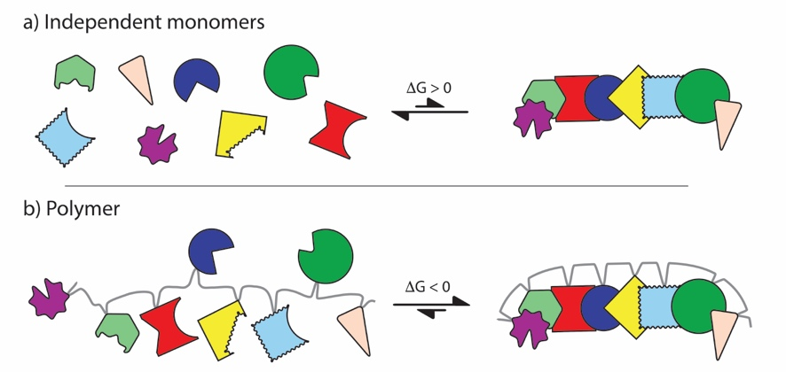
Biopolymers. A solution containing twenty amino acid monomers is isotropic mixture incapable of stereospecific folding or higher-order organization. Upon sequence-specific polymerization, amino acids undergo dramatic transitions in physical behavior. Specific sequences spontaneously collapse into defined three-dimensional structures, giving rise to emergent features such as catalytic pockets, allosteric control, fibers, motors, and other self-assembling biological architectures. Biological structure and function are not intrinsic properties of individual amino acids, but are emergent phenomena born strictly from sequence-specific polymerization.
The colored shapes represent biopolymer building blocks. The gray line represents the biopolymer backbone

Evolution. Evolution is emergence creating machine. The products of evolution are always interdependent multi-component systems that exhibit emergence, where system properties differ fundamentally from the properties of isolated system components. Emergence can be envisioned as passage through a metaphorical door; when a system transitions to a new emergent state, new rules materialize. Emergence gives rise to complex functions that are not evident in the isolated parts of the system. The ribosome, the spliceosome, and the mitochondrion are creative inventions of evolution that demonstrate emergence. The ribosome, the spliceosome, and the mitochondrion stand as witness to the power of evolution to foster emergence. Each biopolymer is an emergent molecule. The structures, functions and properties of biopolymers are different from those of the monomeric building blocks.
To fully appreciate the significance of emergence, one must contrast it with reductionist frameworks that dominated 20th-century science. Scientists sought to collapse complex biological phenomena into basic physical determinism. This mindset was famously articulated by Ernest Rutherford.
- All science is either physics or stamp collecting" (Ernest Rutherford) (3).
- "From the elephant to butyric acid bacterium—it is all the same" (Albert Kluyver) (4).
- "Anything found to be true of E. coli must also be true of elephants" (Jacques Monod) (5).
- "The ultimate aim of the modern movement in biology is to explain all biology in terms of physics and chemistry" (Francis Crick) (6).
- "[Humans] are survival machines—robot vehicles blindly programmed to preserve the selfish molecules known as genes" (Richard Dawkins) (7).
- “Human beings are essentially 'DNA-driven software machines” (J. Craig Venter) (8).
The origins of life. Traditional, reductionist chemistry, the study of isolated molecules, pure single-step reaction mechanisms cannot explain the origins of life. The origins of life is, by definition, an emergent process.

1. Johnson S (2002) Emergence: The connected lives of ants, brains, cities, and software (Simon and Schuster).
2. Smith E & Morowitz HJ (2016) The origin and nature of life on earth: The emergence of the fourth geosphere (Cambridge University Press).
3. Crane T & Mellor D (2002) There is no question of physicalism. Contemporary Materialism 68.
4. Kluyver AJ, Kamp AF, Lariviere JWM, & Verhoeven W (1959) Albert jan kluyver, his life and work: Biographical memoranda, selected papers, bibliography and addenda (North-Holland Publishing Company).
5. Monod J (1971) Chance and necessity: An essay on the natural philosophy of modern biology.
6. Crick F (1966) Of molecules and men. (University of Washington Press, Seattle, WA).
7. Dawkins R (2016) The selfish gene (Oxford university press).
8. Freeman J (2014) J. Craig venter discusses new book on dawn of digital life. UC San Diego Today.

