Origins by Chemical Evolution.
Chemical evolution provides an alternative to direct synthesis of biopolymers. Our goal here is to articulate a general framework of chemical evolution rather than listing of specific chemical pathways. In Chemical evolution (Figure 4), the transformation from prebiotic chemistry to proto-biochemistry was driven at the ensemble, or system, level by prolonged selection and continual regeneration of diversity. Evolution acted on environmentally generated fluxes of molecular ensembles, which were selected on the basis of broad ranges of properties and behaviors, including water solubility, rates of condensation and hydrolysis, catalysis, self-assembly, co-assembly, homochirality, autocatalysis, and other emergent phenomena. Selection and diversification were recursive (1). In this model, there is no teleology; ensembles respond in real time to selective pressures.
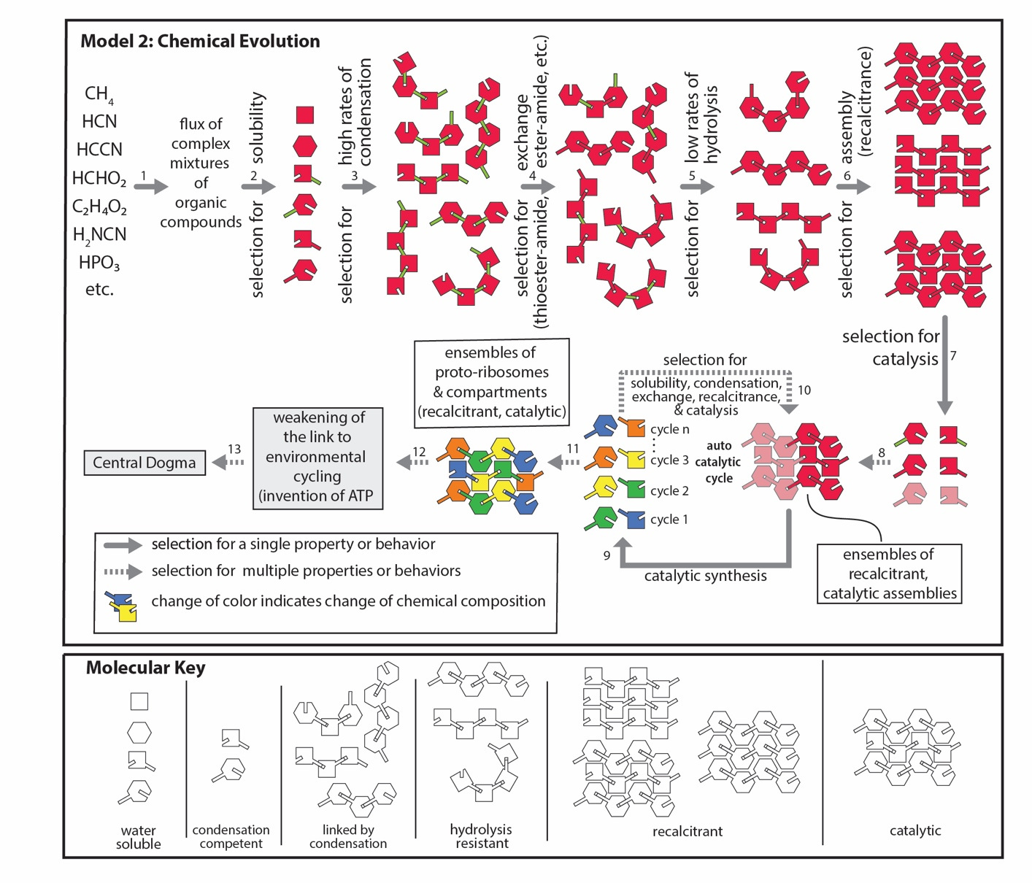Figure 4. A schematic representation of principles of chemical evolution, in which chemical energy is harvested during wet-dry cycling. Wet-dry cycling is not experimentally challenging, and this model is amenable to validation and modification by experiment. A diverse ensemble of small molecules [complex mixtures of organic compounds (CMOC) (5-12)] are subjected to selection. In this framework, CMOC, for example as observed in the asteroid Bennu (2), is sculpted by unremitting selection, with shifting basis. Molecules produced by selection for one criterion are transformed, reselected by a different criterion, re-transformed, and are reselected. In a real system many of the isolated steps shown in this scheme would happen concurrently and competitively, and the products of many steps can directly feed back into previous processes. This model predicts that proto-biopolymers are composed of building blocks that are not necessarily available in the original input CMOC. Step 1: Accumulation of CMOC. Step 2: Selection for solubility in water. Insoluble species are not involved in chemical transformations but remain important because they can contribute to physical partitioning. Step 3: Selection for high rates of condensation during dry phases, for example thioester > ester > peptide. Step 4: Selection for exchange, for example thioester and ester are converted to peptide. Step 5: Selection for low rates of hydrolysis during wet phases (peptide< ester<thioester). Step 6: Selection for assembly. Assembled oligomers are recalcitrant and hydrolyze more slowly than free oligomers (3-5). Step 7: Selection for catalysis. Both synthesis and degradation can be subject to catalytic acceleration. Step 8: Some products for catalysis proceed through steps 2-7 and are incorporated into assemblies. Steps 9 and 10: A small fraction of the catalytic assemblies are self-catalytic and can produce species that contribute to formation and catalysis of the same assembly (6). Self-catalytic assemblies will grow in population over other assemblies. Step 11: Catalytic assemblies and produce species that alter the assemblies and the catalytic output of the assemblies, pushing the system away from the initial chemical composition. Step 12: The conversion of complex functional assemblies to a functional system that is independent of short-term environmental cycling. Step 13: Invention of the central dogma, which is dependent on highly sophisticated polymers produced by chemical evolution. The dashed arrows indicate indirect transitions of unknown mechanism. The dashed arrows represent aggregated processes that are poorly understood. The bottom panel is a key explaining the molecular symbolism. This schematic omits some mechanisms of selection such as compartmentalization. Wet-dry, freeze-thaw, or pressure cycling are examples of possible drivers of chemical evolution.

In chemical evolution, multiple types of oligomers and polymers coexisted, competed and cooperated (Figure 3b). The emergence of biopolymers was protracted, incremental, and progressive (Figure 4). The boundary between chemistry and biology was indistinct. Prebiotic chemistry was continuous with proto-biology. This model integrates chemical principles with evolutionary concepts including variation and selection (7), exaptation (1, 8), extinction (9), symbiosis, entanglement, co-evolution (10), continuity (11), absence of foresight (12), and creativity (13, 14). In this model, most of the molecular “ancestors” of today’s biopolymers are likely to be extinct - we observe only their distantly related progeny. Chemical evolution is continuous with Darwinian evolution.
In the chemical evolution model, fluxes of complex mixtures of organic compounds (CMOCs) (2, 15-17) were sculpted and transformed in a prolonged and undulating process to generate polymer backbones and sidechains (3, 4, 18-20). In a simple version of the model, chemical evolution was planet wide. Surfaces covered with CMOC were subjected to oscillating water activity on a temperate spinning planet in proximity to the sun. Bonds formed during dry phases and bonds broke during wet phases. Initially there was no clear boundary between the evolving system and the environment—the chemical system was part of the environment. A weakening of the link between the chemical system and the environment conferred advantage by facilitating persistence during unfavorable conditions such as acute temperature variation or periods of reduced flux of CMOC, and led eventually to the emergence of membranes, pumps, pores, and metabolism, to create a system distinct from the environment.

Requirements of Origins by Chemical Evolution.
The model of origins of life by chemical evolution is driven by ordinary environmental cycles—day-night and seasonal rhythms—whose variability across latitude and local geography provides broad scope for chemical exploration. In this model, evolving chemical systems display foundational features that foreshadow biological evolution. A generation corresponds to a single environmental cycle; information resides in the non-random composition of molecular ensembles (variation) that can persist across cycles through kinetic trapping (inheritance); fitness is reflected in the differential survival and accumulation of compounds or ensembles across repeated cycles; and replication emerges as a late evolutionary innovation for enhancing persistence. Selection arises naturally when molecules differ in their propensity to form during condensation reactions, their intrinsic resistance to hydrolysis, and their participation in recalcitrant assemblies or autocatalytic networks. These parallels suggest that core principles of evolution—variation, selection, and inheritance—can arise prior to life, embedded in the dynamics of complex chemical systems shaped by their environments.
Selection. Selection is intrinsic to both Darwinian and chemical evolution (7, 21). As in biology, selection in chemical evolution operates continuously on adapting, perpetually shifting heterogeneous systems. As illustrated in Figure 4, early phases of prebiotic chemical evolution select and transform mixtures based on several properties: (i) solubility in water, (ii) propensity to undergo condensation–dehydration reactions, (iii) capacity for chemically catalyzed transitions—such as ester–amide exchange—that produce kinetically trapped species, (iv) resistance to hydrolysis conferred by molecular assembly, and eventually, (v) emergence of autocatalytic and heterocatalytic pathways for precursor synthesis. The dynamic nature of selection in chemical evolution parallels Darwinian evolution, in which shifting environmental conditions cause population characteristics to continuously reshape fitness landscapes. As Jacob suggested (12), a creative molecular phase of chemical evolution preceded creative sequence-based Darwinian evolution. In the model proposed here, chemical evolution can create complex biological molecules such as nucleic acids and proteins whose formation is challenging via direct chemical synthesis on the early Earth.
Catalysis. In this model, chemical evolution, driven in part by selection for resistance to hydrolysis, produces recalcitrant assemblies. These same assemblies also confer catalytic advantages. Catalytic proficiency increases dramatically with assembly (22, 23). The assembly-catalysis coupling is indicated by the prevalence of catalysis across assemblies of biopolymer classes and in non-biological systems: catalytic DNAs (24), catalytic RNAs (25, 26), catalytic glycans (27-29), catalytic peptides (30), catalytic proteins (31), catalytic micelles and coacervates (32, 33), and catalytic minerals (34). The generality of this phenomenon is striking: in the presence of Fe²⁺, all structured RNAs can catalyze electron transfer (35, 36), suggesting that catalysis is an emergent property of assembly.

1. Frenkel-Pinter M, Petrov AS, Matange K, Travisano M, Glass JB, & Williams LD (2022) Adaptation and exaptation: From small molecules to feathers. J Mol Evol 90: 166-175.
2. Glavin DP, Dworkin JP, Alexander CMOD, Aponte JC, Baczynski AA, Barnes JJ, Bechtel HA, Berger EL, Burton AS, & Caselli P (2025) Abundant ammonia and nitrogen-rich soluble organic matter in samples from asteroid (101955) bennu. Nature Astronomy 1-12.
3. Matange K, Marland E, Frenkel-Pinter M, & Williams LD (2025) Biological polymers: Evolution, function, and significance. Acc Chem Res 58: 659-672.
4. Edri R, Fisher S, Menor‐Salvan C, Williams LD, & Frenkel‐Pinter M (2023) Assembly‐driven protection from hydrolysis as key selective force during chemical evolution. FEBS Lett 597: 2879-2896.
5. Brack A & Spach G (1980) β-structures of polypeptides with l-and d-residues: Part III. Experimental evidences for enrichment in enantiomer. J Mol Evol 15: 231-238.
6. Walker SI, Grover MA, & Hud NV (2012) Universal sequence replication, reversible polymerization and early functional biopolymers: A model for the initiation of prebiotic sequence evolution. PLoS One 7: e34166.
7. Price GR (1995) The nature of selection. J Theor Biol 175: 389-396.
8. Gould SJ & Vrba ES (1982) Exaptation—a missing term in the science of form. Paleobiology 8: 4-15.
9. Raup DM (1994) The role of extinction in evolution. Proc Natl Acad Sci USA 91: 6758-6763.
10. Lanier KA, Petrov AS, & Williams LD (2017) The central symbiosis of molecular biology: Molecules in mutualism. J Mol Evol 85: 8-13.
11. Wolf YI & Koonin EV (2007) On the origin of the translation system and the genetic code in the RNA world by means of natural selection, exaptation, and subfunctionalization. Biol Direct 2: 1-25.
12. Jacob F (1977) Evolution and tinkering. Science 196: 1161-1166.
13. Gould SJ (2002) The structure of evolutionary theory (Harvard University Press).
14. Dobzhansky T (1974) Chance and creativity in evolution. Studies in the philosophy of biology: Reduction and related problems 307-338.
15. Wogan NF, Catling DC, Zahnle KJ, & Lupu R (2023) Origin-of-life molecules in the atmosphere after big impacts on the early earth. The Planetary Science Journal 4: 169.
16. Zahnle KJ, Lupu R, Catling DC, & Wogan N (2020) Creation and evolution of impact-generated reduced atmospheres of early earth. Planet Sci J 1: 1-11.
17. Genda H, Brasser R, & Mojzsis S (2017) The terrestrial late veneer from core disruption of a lunar-sized impactor. Earth Planet Sci Lett 480: 25-32.
18. Szathmáry E & Smith JM (1995) The major evolutionary transitions. Nature 374: 227-232.
19. Runnels CM, Lanier KA, Williams JK, Bowman JC, Petrov AS, Hud NV, & Williams LD (2018) Folding, assembly, and persistence: The essential nature and origins of biopolymers. J Mol Evol 86: 598-610.
20. Hud NV, Cafferty BJ, Krishnamurthy R, & Williams LD (2013) The origin of RNA and “my grandfather’s axe”. Chem Biol 20: 466-474.
21. Abkevich VI, Gutin AM, & Shakhnovich EI (1996) How the first biopolymers could have evolved. Proc Natl Acad Sci USA 93: 839-844.
22. Ottelé J, Hussain AS, Mayer C, & Otto S (2020) Chance emergence of catalytic activity and promiscuity in a self-replicator. Nature Catalysis 3: 547-553.
23. Adamski PR, Eleveld MJ, Bos J, Mikhailov K, Kiani A, Ottelé J, & Otto S (2023) Catalysis as a robust feature and catalytic promiscuity as a recurrent trait in peptide based self-replicators. BioRxiv.
24. Khan S, Burciu B, Filipe CD, Li Y, Dellinger K, & Didar TF (2021) Dnazyme-based biosensors: Immobilization strategies, applications, and future prospective. Acs Nano 15: 13943-13969.
25. Cech TR (1986) RNA as an enzyme. Sci Am 255: 64-75.
26. Guerrier-Takada C, Gardiner K, Marsh T, Pace N, & Altman S (1983) The RNA moiety of ribonuclease P is the catalytic subunit of the enzyme. Cell 35: 849-857.
27. Bai CC, Tian BR, Zhao T, Huang Q, & Wang ZZ (2017) Cyclodextrin-catalyzed organic synthesis: Reactions, mechanisms, and applications. Molecules 22: 1475.
28. Yang Z-J, Zeng H, Zhou X-T, & Ji H-B (2013) Enhanced catalytic activity and recyclability for oxidation of cinnamaldehyde catalysed by β-cyclodextrin cross-linked with chitosan. Supramol Chem 25: 233-245.
29. Liu K & Delbianco M (2025) A glycan foldamer that uses carbohydrate–aromatic interactions to perform catalysis. Nat Chem.
30. Zozulia O, Dolan M, & Korendovych I (2018) Catalytic peptide assemblies. Chemical Society Reviews 47: 3621-3639.
31. Nelson DL, Lehninger AL, & Cox MM (2021) Principles of Biochemistry (Macmillan).
32. Shen T, Zhou S, Ruan J, Chen X, Liu X, Ge X, & Qian C (2021) Recent advances on micellar catalysis in water. Advances in Colloid and Interface Science 287: 102299.
33. Smokers IBA, Visser BS, Slootbeek AD, Huck WTS, & Spruijt E (2024) How droplets can accelerate reactions─coacervate protocells as catalytic microcompartments. Acc Chem Res 57: 1885-1895.
34. Rao KRPM, Huggins FE, Mahajan V, Huffman GP, & Rao VUS (1994) The role of magnetite in fischer-tropsch synthesis. Hyperfine Interact 93: 1745-1749.
35. Athavale SS, Petrov AS, Hsiao C, Watkins D, Prickett CD, Gossett JJ, Lie L, Bowman JC, O'neill E, & Bernier CR (2012) RNA folding and catalysis mediated by iron (II). PLoS One 7: e38024.
36. Hsiao C, Chou IC, Okafor CD, Bowman JC, O'neill EB, Athavale SS, Petrov AS, Hud NV, Wartell RM, Harvey SC, & Williams LD (2013) RNA with iron(II) as a cofactor catalyses electron transfer. Nat Chem 5: 525-528.

