Survivorship bias
Survivorship bias is the tendency to focus on what has endured while discounting what has been lost (1). We study billionaires to identify keys to success. We identify college dropouts, risk-takers and visionary leaders. We ignore the vast population of dropouts working at low paying jobs, risk-takers who went bankrupt and visionaries whose ideas led to catastrophe. Visible successes inform the narrative; failures are invisible.
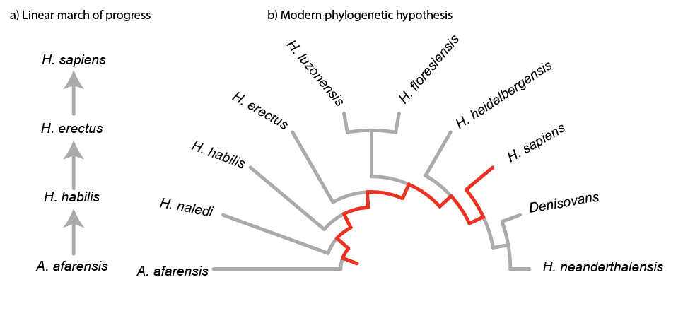
Until recently, Homo sapiens (survivors) fancied themselves as privileged and unique. Human evolution was thought to proceed via a linear 'march of progress' (Figure 1a) (2). We now know, through both paleontological and genomic data, that H. sapiens represent a twig, not a trunk, of primate evolution (Figure 1b) (3) and are distinct by contingency, not destiny.
Figure 1. a) Linear "march of progress" model representing the mid-20th century view of human evolution as a single progressive lineage with one species directly ancestral to the next. b) Current working phylogenetic hypothesis for genus Homo based on fossil and genetic evidence. The modern view is a complex, branching evolutionary pathway with multiple coexisting species, including extinct lineages. H. sapiens (red pathway) is the sole surviving member of a diverse genus. Some phylogenetic relationships remain actively debated. A. afarensis serves as the outgroup.
Survivorship bias shapes many models of the origins of life; extant biopolymers (survivors) are said to be chemically privileged and functionally unique—they were destined to rule biochemistry (Figure 2a). In an evolutionary model, by contrast, many combinations of polymers coexisted (Figure 2b) and no single combination was destined to survive. Unfortunately, molecules leave no fossils, so we cannot distinguish these models by excavating a graveyard of alternative biopolymers.
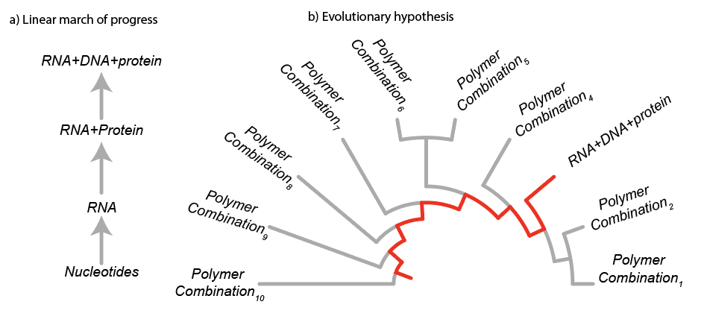
A sole surviving biochemical lineage cannot establish chemical or biochemical inevitability. It can demonstrate sufficiency, but not necessity or destiny. It seems possible or even likely that today’s biopolymers were one functional combination among many (Figure 2b) and that our extant biopolymer combination endured while others went extinct. This scenario is consistent with evidence that the genetic code, the backbones of nucleic acids and proteins, and the amino acid alphabet are products of evolution (4-7). Evolution requires extinction (8). Extinction is often contingent (9-11).
Figure 2. a) A linear "march of progress" model representing the origins of life as single lineage. b) An alternative hypothesis of chemical evolution. RNA/DNA/Protein is the sole surviving polymer set. Each number corresponds to a different set of polymers.
The evolution and persistence of RNA, DNA, and proteins must reflect a balance of chemical constraints and historical contingencies. Alternative combinations of biopolymers or ribosomal systems (Figure 2b), even more efficient and robust than the survivors, could have been eliminated by chance events such as impacts, just as non-avian dinosaurs were displaced from their position of dominance (10). The endurance of RNA and proteins does not prove that they are privileged and unique. Lottery winners prove only that winning is possible, but do not reveal how to win, nor that winners constitute a special class. Success does not illuminate the pathway through randomness, nor does it imply optimality. Our argument here concerns survivorship bias, not equiprobability of outcomes; chemical evolution proceeds on a landscape constrained by prebiotic chemistry, geochemistry, kinetics, and thermodynamics along with contingency. At present, we lack sufficient information to weigh the relative roles of constraint and contingency (9, 12) in shaping biochemistry and the origins of life.

1. Lockwood D (2021) Fooled by the winners: How survivor bias deceives us (Greenleaf Book Group).
2. Huxley TH (1863) Evidence as to man's place in nature (Williams and Norgate).
3. Wood B & Smith RJ (2022) Towards a more realistic interpretation of the human fossil record. Quaternary Science Reviews 295: 107722.
4. Freeland SJ & Hurst LD (1998) The genetic code is one in a million. J Mol Evol 47: 238-248.
5. Matange K, Marland E, Frenkel-Pinter M, & Williams LD (2025) Biological polymers: Evolution, function, and significance. Acc Chem Res 58: 659-672.
6. Philip GK & Freeland SJ (2011) Did evolution select a nonrandom “alphabet” of amino acids? Astrobiology 11: 235-240.
7. Makarov M, Sanchez Rocha AC, Krystufek R, Cherepashuk I, Dzmitruk V, Charnavets T, Faustino AM, Lebl M, Fujishima K, & Fried SD (2023) Early selection of the amino acid alphabet was adaptively shaped by biophysical constraints of foldability. J Am Chem Soc 145: 5320-5329.
8. Fitch WM & Ayala FJ (1995) Tempo and mode in evolution: Genetics and paleontology 50 years after Simpson.
9. Macgillavry T (2025) Contingency, determinism, and constraint in the evolution of elaborate courtship phenotypes. Evolution qpaf064.
10. Chiarenza AA, Mannion PD, Lunt DJ, Farnsworth A, Jones LA, Kelland S-J, & Allison PA (2019) Ecological niche modelling does not support climatically-driven dinosaur diversity decline before the cretaceous/paleogene mass extinction. Nat Commun 10: 1091.
11. Black BA, Elkins-Tanton LT, Rowe MC, & Peate IU (2012) Magnitude and consequences of volatile release from the Siberian traps. Earth Planet Sci Lett 317: 363-373.
12. Blount ZD, Borland CZ, & Lenski RE (2008) Historical contingency and the evolution of a key innovation in an experimental population of Escherichia coli. Proc Natl Acad Sci USA 105: 7899-7906.

