Macromolecules, Polymers and Biopolymers
[not final] The origins of life is equivalent to the origins of biopolymers. Understanding the origins of life requires an understanding of biopolymers. Cartoons like the central dogma and RNA information/catalysis are not especially helpful in this effort. We need to understand distinctions between macromolecules and polymers and between abiotic, synthetic and biological polymers. We need to understand the essential and wholistic nature and fantastical properties of biopolymers.
Macromolecules. A macromolecule is a large molecule composed of chemical elements that are not necessarily repeating. Kerogens (1) are complex mixtures of macromolecules derived from biological systems that have been deposited in sediments and transformed through diagenesis. Melanoidins (2) are complex mixtures of macromolecules formed by condensation reactions between sugars and amino acids. Tholins (3) contain macromolecules produced by irradiation of mixtures of N₂, CH₄, CO, and CO₂. Kerogen and melanoidins are biologically sourced. Tholins are abiotic and are found on Titan and elsewhere in the solar system. Macromolecules cannot form specific assemblies.
Polymers: A polymer s a large molecule composed of repeating structural units (called monomers, residues, or building blocks) connected by repetitive covalent bonds (4). Polymers have backbones and repeat chemistry. Polymers can be linear or branched and can be very large, with molecular weights of millions of Daltons. Polypropylene (5), nylon (6), and Teflon (7) are synthetic polymers. Minerals like silica (8), with (-O-Si-O-Si)_{n} repeats, can be considered a abiotic inorganic polymers in three-dimensional networks. There are very few examples of abiotic non-synthetic linear polymers on Earth. To our knowledge sulfur (9), selenium (10), and tellurium (11) are the only abiotic polymers detected on extant Earth.
Abiotic polyphosphate can be generated under high-temperature and dehydrating conditions and has been observed in the laboratory and inferred in geochemical contexts (12). However, there is no clear evidence that polyphosphate exists as a persistent species or has accumulated as a significant abiotic polymer in natural environments on Earth (13).
Hi Loren
Good to hear from you! So last year (more specifically Oct 2024-Oct 2025) was a year I'd love to forget. Tough 12 months but I'm doing better now. How are things for you?

So that's a good question- I did hear once of attempts to make glycol-phosphate polymers (ref below). They can be formed but never saw any practical applications if I remember correctly.

So for polyphosphates the largest that have been observed geologically and are presumed abiotic are (linear) triphosphate or (cyclic) tetrametaphosphate (refs below). Nothing bigger. In my opinion, the conditions that are required for polyphosphate formation—hot, dry, without an excess of divalent cations—may push instead to cyclization instead of linear polymers. There's probably a sweet spot, environmentally, that could permit linear polyphosphate formation, but it's likely not common.

Biologic polyphosphates are pretty common, and I think get close to 100 phosphate units. Kornberg did much of the work there, with his students continuing.

Hope that helps!
Matt

Biopolymers: The universal biopolymers of life are RNA, DNA, polypeptide and polysaccharide. Biopolymers are composed of homochiral monomers, and contain C, H O, and N (and sometimes P), are linear and directional, and are made by condensation dehydration reactions that are unfavorable in water but are driven in vivo by hydrolysis of ATP, GTP or UTP.
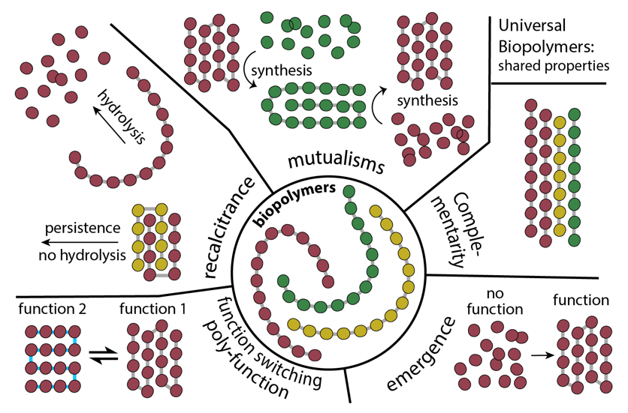
Biopolymers have the following properties:
- Complementarity. Complementarity is a structural and chemical matching between molecular surfaces that enables specific, noncovalent association (14). Cohesive (self) complementarity is seen in α-helices, β-sheets, base pairs and cellulose. Adhesive (non-self) complementarity is seen in RNA-protein complexes, DNA protein complexes, etc.
- Homochirality. Homochirality is necessary for complementarity. A racemic polypeptide of 100 amino acids is a mixture of 2¹⁰⁰ different molecules. Diverse ensembles cannot assemble specifically.
- Recalcitrance: One of the most astounding proficiencies of biopolymers is their ability to manipulate their own kinetic trapping (15-17). Unfolded mRNA hydrolyzes quickly, whereas folded rRNA and tRNA hydrolyze slowly. Glycosidic bonds between glucoses hydrolyze far more slowly in cellulose (assembled) than in glycogen (not assembled). Polypeptide follows the same pattern. Protein fibers and amyloids are most resistant to hydrolysis. Recalcitrance is based on complementarity – assemblies, built on complementarity, resist chemical transformations.
- Mutualisms. A cell is a consortia of biopolymers in mutualism relationships (18). Protein is made by RNA in the ribosome. RNA is made by protein in RNA polymerase. Amino acids are consumed to made nucleotides. Nucleotides are consumed to make amino acids. Biochemistry is an irreducible biopolymer network.
- Function switching: A general characteristic of universal biopolymers is the capacity to fundamentally remodel structural and functional landscapes via extremely subtle chemical changes (15). Removing one atom of the RNA backbone to form the DNA backbone changes assembly states, helical form, hydrolytic lifetime, and catalytic proficiency. Changing the anomeric linkage of polyglucose from α(1,4) to β(1,4) changes the assembly state, hydrolytic lifetime, and functions. Conversion of polyalanine to polyglycine converts α-helix to intrinsic disorder.
- Coding: Coding is the specification of building block sequences within biopolymers (19).
- Emergence. The properties of biopolymers cannot be predicted from the properties of building blocks (15).
Biopolymers are in a special chemical space that is very remote from known abiotic chemical systems. Biopolymers appear to be beyond the creative capacity of abiotic chemistry and beyond our ability to engineer or comprehend. For example we cannot predict protein or RNA folding from first principles. Machine-learning tools such as AlphaFold are not first-principles solutions; they interpolate within the historical record of evolved biopolymers. They are based on pattern recognition, not fundamental physical derivation.
The Origins of Life. There are two broad classes of OOL models that are relevant here. In one broad class, one or more biopolymers arose via fortuitous chemical processes and initiated Darwinian evolution. In a second broad class of models, biopolymers are the product of intense and prolonged chemical co-evolution. In this model, a broad array of ancestral proto-biopolymers is now extinct.
In our view the first model is a just-so story of vanishingly low probability. This model is characterized by survivorship bias, teleology, discontinuity and chicken/egg fallacies. The second model requires a process of chemical evolution about which we know very little. We cannot use chemical evolutionary processes in the lab to generate molecules with the properties approaching biopolymers.
Darwinian evolution presupposes biopolymers—it cannot begin without replicating systems capable of heredity and variation. The central problem of the origins of life is not the origin of replication per se. It is the origin of biopolymeric matter with the properties and relationships required for replication. We are faced with an explanatory gap: Darwinian evolution explains the refinement of biopolymers but not their origins. One can propose a non-Darwinian chemical evolutionary processes that operated before the emergence of template-directed replication, but must validate that proposal via experiment. Efforts to accomplish this are ongoing in multiple laboratories.
References
1. Vandenbroucke M & Largeau C (2007) Kerogen origin, evolution and structure. Org Geochem 38: 719-833.
2. Wang H-Y, Qian H, & Yao W-R (2011) Melanoidins produced by the maillard reaction: Structure and biological activity. Food Chem 128: 573-584.
3. Cable ML, HöRst SM, Hodyss R, Beauchamp PM, Smith MA, & Willis PA (2012) Titan tholins: Simulating titan organic chemistry in the cassini-huygens era. Chem Rev 112: 1882-1909.
4. Flory PJ (1953) Principles of polymer chemistry (Cornell university press).
5. Maddah HA (2016) Polypropylene as a promising plastic: A review. Am J Polym Sci 6: 1-11.
6. Shakiba M, Rezvani Ghomi E, Khosravi F, Jouybar S, Bigham A, Zare M, Abdouss M, Moaref R, & Ramakrishna S (2021) Nylon—a material introduction and overview for biomedical applications. Polym Adv Technol 32: 3368-3383.
7. Puts GJ, Crouse P, & Ameduri BM (2019) Polytetrafluoroethylene: Synthesis and characterization of the original extreme polymer. Chem Rev 119: 1763-1805.
8. Deer WA, Howie RA, & Zussman J (2013) An introduction to the rock-forming minerals (Mineralogical Society of Great Britain and Ireland).
9. Meyer B (1976) Elemental sulfur. Chem Rev 76: 367-388.
10. Winkel LH, Johnson CA, Lenz M, Grundl T, Leupin OX, Amini M, & Charlet L (2012) Environmental selenium research: From microscopic processes to global understanding. (ACS Publications).
11. Yi S, Zhu Z, Cai X, Jia Y, & Cho J-H (2018) The nature of bonding in bulk tellurium composed of one-dimensional helical chains. Inorg Chem 57: 5083-5088.
12. Pasek MA (2008) Rethinking early earth phosphorus geochemistry. Proc Natl Acad Sci USA 105: 853-858.
13. Achbergerová L & Nahálka J (2011) Polyphosphate-an ancient energy source and active metabolic regulator. Microbial cell factories 10: 63.
14. Runnels CM, Lanier KA, Williams JK, Bowman JC, Petrov AS, Hud NV, & Williams LD (2018) Folding, assembly, and persistence: The essential nature and origins of biopolymers. J Mol Evol 86: 598-610.
15. Matange K, Marland E, Frenkel-Pinter M, & Williams LD (2025) Biological polymers: Evolution, function, and significance. Acc Chem Res 58: 659-672.
16. Edri R, Williams LD, & Frenkel-Pinter M (2024) From catalysis of evolution to evolution of catalysis. Acc Chem Res 57: 3081-3092.
17. Guth-Metzler R, Mohamed AM, Cowan ET, Henning A, Ito C, Frenkel-Pinter M, Wartell RM, Glass JB, & Williams LD (2023) Goldilocks and RNA: Where Mg2+ concentration is just right. Nucleic Acids Res 51: 3529-3539.
18. Lanier KA, Petrov AS, & Williams LD (2017) The central symbiosis of molecular biology: Molecules in mutualism. J Mol Evol 85: 8-13.
19. Crick F (1970) Central dogma of molecular biology. Nature 227: 561.

