Water

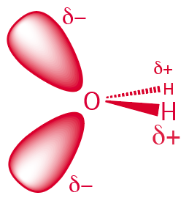
Water established, shaped, and continues to constrain biochemistry and biophysics. Water is at once commonplace and strange. It is everywhere in daily life, condensing on cold beer cans, forming clouds, rain, lakes, and oceans, and sustaining all known life. It covers most of Earth’s surface. Water is the third most abundant molecule in the universe, after H₂ and CO (1, 2). It is deeply embedded in chemistry, biology, ecology, culture and the economy. This everyday familiarity obscures physical and chemical properties that are profoundly unusual— unlike those of any other known substance.
The role of water in core of biochemistry has remained invariant across the tree of life, from the last universal common ancestor (LUCA) to the present, and from bacteria to archaea and eukarya. For nearly four billion years, water has been the dominant physical medium of biology - the primary bulk phase in which biochemical reactions occur, constituting the major constituent of living matter by mass (3-5). All of biology depends on the aqueous coordination of metal cations such as Na⁺, K⁺, Mg²⁺, Ca²⁺, and Zn²⁺, whose hydration shells determine effective size, charge distribution, and reactivity (6). Nowhere do we find biology that forms peptide, phosphodiester, or glycosidic bonds by mechanisms other than dehydration condensation (3, 7). Everywhere in biology, energy transduction depends on water as a nucleophile—ATP hydrolysis, GTP hydrolysis, and phosphoryl transfer all exploit water's reactivity to break high-energy bonds (7). Everywhere in biology we find membranes stabilized by the hydrophobic effect (7). Nowhere in biology do we find buffering, acid–base homeostasis, or redox equilibria independent of water’s amphoteric, dielectric, and hydration properties, which define proton mobility, pH and pKa scales, and redox reference potentials.
Figure 1. A water molecule has two bonding orbitals and two non-bonding orbitals.
Water, through the hydrophobic effect, uniquely drives protein folding (8, 9), and drives nucleic acid and membrane assembly. Biopolymers spontaneously adopt highly ordered conformations with low configurational entropy, as hydrophobic interactions stabilize specific states while excluding others. Enzymes contain well-defined hydrophobic interiors, hydrophilic exteriors, and catalytic clefts that exclude or specifically localize water (10, 11). Water stabilizes transition states in enzymatic reactions by organizing electrostatic fields, mediating proton transfer, and forming transient hydrogen bonds (12). Water has endowed the Earth with dissolved salts and electrolytes (13), compartmentalization (14), and phase separation (15). Water's context-dependent effects include on-water versus in-water catalysis (16) and the contrast between dilute solutions and high-solids/low-water matrices (17)
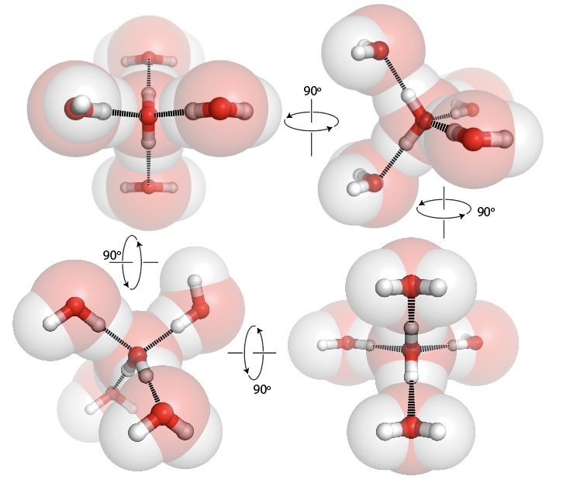
These diverse phenomena, taken together, suggest that water defines the chemical landscapes within which life and its origins can be understood. The profound entanglement of life with water means that its properties imposed not only diverse possibilities but powerful constraints during life’s emergence. While it might appear that the properties of water are finely tuned to support life, in fact water predated life, and life emerged and evolved in response to water’s physical and chemical characteristics. The causality runs from water to biochemistry, not the reverse: only certain molecular species and reaction networks could persist and evolve within it. Consequently, biology is composed of molecules that exploit, cooperate with, and resist water’s unique properties. These roles are not evolutionary accidents that became frozen in place—they reflect the physicochemical landscape established by water from the beginning. Dehydration–condensation, hydrolysis, the hydrophobic effect, amphoterism, and aqueous ion chemistry were not “chosen” by evolution but defined the stage upon which evolution could initiate and progress.
Figure 2. In the condensed state (solid or liquid) a water molecule, with pseudo-tetrahedral point symmetry forms cohesive interactions (hydrogen bonds) with other water molecules in pseudo-tetrahedral space symmetry.

References

1. Ceccarelli C (2020) Water in the universe. Encyclopedia of astrobiology, eds Gargaud M, Irvine WM, Amils R, Claeys P, Cleaves HJ, Gerin M, Rouan D, Spohn T, Tirard S, & Viso M (Springer Berlin Heidelberg, Berlin, Heidelberg), pp 1-5.
2. Omont A (2007) Molecules in galaxies. Rep Prog Phys 70: 1099.
3. Frenkel-Pinter M, Rajaei V, Glass JB, Hud NV, & Williams LD (2021) Water and life: The medium is the message. J Mol Evol 1-10.
4. Ball P (2017) Water is an active matrix of life for cell and molecular biology. Proc Natl Acad Sci USA 114: 13327-13335.
5. Milo R & Phillips R (2015) Cell biology by the numbers (Garland Science).
6. Lippard SJ & Berg JM (1994) Principles of bioinorganic chemistry (University Science Books).
7. Nelson DL, Lehninger AL, & Cox MM (2021) Lehninger principles of Biochemistry, 8th edition (Macmillan).
8. Rose GD, Fleming PJ, Banavar JR, & Maritan A (2006) A backbone-based theory of protein folding. Proc Natl Acad Sci USA 103: 16623-16633.
9. Baldwin RL & Rose GD (2016) How the hydrophobic factor drives protein folding. Proc Natl Acad Sci USA 113: 12462-12466.
10. Fersht A (1985) Enzyme structure and mechanism (W. H. Freeman and Co., New York) 2nd ed. Ed.
11. Lee D, Redfern O, & Orengo C (2007) Predicting protein function from sequence and structure. Nat Rev Mol Cell Biol 8: 995-1005.
12. Ball P (2008) Water as an active constituent in cell biology. Chem Rev 108: 74-108.
13. Wright MR (2007) An introduction to aqueous electrolyte solutions (John Wiley & Sons).
14. Menon G, Okeke C, & Krishnan J (2017) Modelling compartmentalization towards elucidation and engineering of spatial organization in biochemical pathways. Sci Rep 7: 12057.
15. Hatters DM (2023) Grand challenges in biomolecular condensates: Structure, function, and formation. Frontiers in Biophysics 1: 1208763.
16. Butler RN & Coyne AG (2010) Water: Nature’s reaction enforcer comparative effects for organic synthesis “in-water” and “on-water”. Chem Rev 110: 6302-6337.
17. Slade L, Levine H, & Reid DS (1991) Beyond water activity: Recent advances based on an alternative approach to the assessment of food quality and safety. Critical Reviews in Food Science & Nutrition 30: 115-360.

